**General Questions:**

**1. What other health systems are you currently working with?**

* Kaleida Health, Buffalo, New York.
  + Kaleida wins ‘[Most Wired Innovator](https://www.hhnmag.com/articles/8482-buffalo-system-aids-hospital-visitors-in-finding-their-way)’ award after deploying the Jibestream solution
* Veterans’ Affairs Hospital(s) – Numerous, Federal
  + It is important to note that Orlando VA hospital is the testbed for innovation for the rest of the VA hospitals in the country. Orlando VA has selected Jibestream as their long-term mapping partner after an extensive evaluation process.
* Department of Defense Hospital(s) – Numerous, Federal
* Lee Health, Lee County, Florida
* And More...

**2. What clients outside of healthcare do you work with?**

Few of our notable clients:

* Westfield and One Market (1000+ venues) - Retail
* GGP (159 venues) – Retail
* Marriott International – Hospitality, ongoing
* The Pentagon – corporate
* LinkedIn HQ (74 buildings worldwide) – ongoing
* Facebook HQ, NATO, FedEx, Ernst & Young
* San Francisco Airport
* And more…

**3. Can you show us a few examples of companies that are similar in size, which you have implemented wayfinding for?**

1. [Kalida Web](https://www.ochbuffalo.org/wayfinding) ([https://www.ochbuffalo.org/wayfinding](https://urldefense.proofpoint.com/v2/url?u=https-3A__www.ochbuffalo.org_wayfinding&d=DwMGaQ&c=vq5m7Kktb9l80A_wDJ5D-g&r=974WgKX7aIbY8oK79ZFzo2UhSFNFtYY5_iptiCK6z0o&m=qbas5FHN7sFw_bui0DriloTfB9Xijw6IRUM39czIlJ4&s=qx6244tAnPVN7UcM05WsL8qmQhYk1h5IduRpE4y2Qp8&e=)

[Kaleida iOS and Android](https://www.kaleidahealth.org/mykaleida/app/)

1. [GGP iOS](https://itunes.apple.com/ca/app/ggp-malls/id400510894?) (https://itunes.apple.com/ca/app/ggp-malls/id400510894?)

[GGP Android](https://play.google.com/store/apps/details?id=com.ggp.theclub&) (https://play.google.com/store/apps/details?id=com.ggp.theclub&)

GGP web example: [Tyson Galleria](https://www.tysonsgalleria.com/en/directory) (<https://www.tysonsgalleria.com/en/directory/>)

1. [Westfield US iOS](https://itunes.apple.com/ca/app/westfield-us/id397494939?) (https://itunes.apple.com/ca/app/westfield-us/id397494939?)

[Westfield US Android](https://play.google.com/store/apps/details?id=com.westfieldlabs.us.centre) (https://play.google.com/store/apps/details?id=com.westfieldlabs.us.centre)

[Westfield UK iOS](https://itunes.apple.com/ca/app/westfield-uk/id409824812?) (https://itunes.apple.com/ca/app/westfield-uk/id409824812?)

[Westfield UK Android](https://play.google.com/store/apps/%20details?id=com.westfieldlabs.uk.centre) (https://play.google.com/store/apps/details?id=com.westfieldlabs.uk.centre)

[Westfield AU iOS](https://itunes.apple.com/us/app/westfield-au/%20id390301687?) (https://itunes.apple.com/us/app/westfield-au/id390301687?)

[Westfield AU Android](https://play.google.com/store/apps/details?id=com.westfieldlabs.au.centre) (<https://play.google.com/store/apps/details?id=com.westfieldlabs.au.centre>)

Westfield web example: [San Francisco Center](https://www.westfield.com/sanfrancisco/center-info/map/49ers-team-store/51709#!/sanfrancisco) (<https://www.westfield.com/sanfrancisco/center-info/map/49ers-team-store/51709#!/sanfrancisco>)

**4. How many employees do you have?**

37 **Implementation and Support:**

**5. What type of infrastructure does your Wayfinding solution use?**

The Jibestream solution is [open and agnostic](https://www.jibestream.com/partner-ecosystem) to any infrastructure. This is one of our many strengths because we can leverage your existing infrastructure (WiFi, RTLS, BLE) and add additional infrastructure to bring you the best solution.

We can work with and have worked with BLE, Virtual Beacons (Mist), Ultrasound (Sonitor), UWB (Zebra), WiFi (Cisco) and many more.

The newest infrastructure in this market is ‘Smart Lighting’. Large lighting companies build lights with BLE beacons in them. This means that there will be no need to replace the batteries in the battery-bowered BLE beacons (most-commonly used).Jibestream is partnered with its’ manufacturers such as OSRAM Sylvania, Enlighted by Siemens, Lunera and a few others.

**6. If your solution requires beacons throughout the facility do you provide them, or do you have a preferred vendor?**

Both. We provide them or can refer you to a vendor – whichever works best for your organization. Our preferred vendors include kontakt.io, Mist and the smart lighting companies mentioned above.

**7. How involved are you from beginning to end in setting up Wayfinding for a facility?**

Jibestream takes pride in being heavily involved from beginning to end till our partners and clients succeed. At Jibestream we call this the White Glove Service. We assign a dedicated project manager who will be with you while the project is ongoing and a customer success manager right after we have successfully deployed.

Our team is very experienced in this industry and can be fully relied on. Jibestream is more than happy to provide references where clients can attest to our excellent service.

**8. How are you involved in helping us blueprint our locations as we prepare for implementation?**

Please refer to answer from question 7.

**9. What is the process of updating floor plans?**

Jibestream CMS offers a feature called ‘Map Editor’. This allows users to update floor plans temporarily or permanently and push changes in real time. The CMS is built keeping in mind that the end user is not technical.

If you’d like for us to do it, MemorialCare can contract Jibestream for updates. See example of the Map Editor in the CMS below:

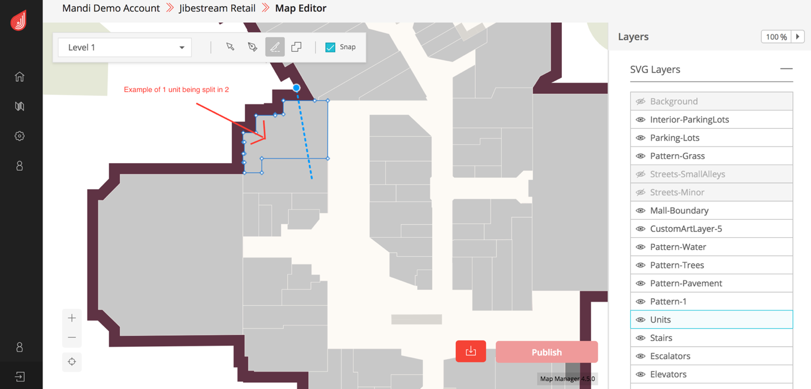

**… continued below…**

**10. What does your support team/system look like?**

See image below for a high-level overview. Our support team is run by our Director of Customer Success, [Lesley Browne](https://www.linkedin.com/in/lesleybrowne/)

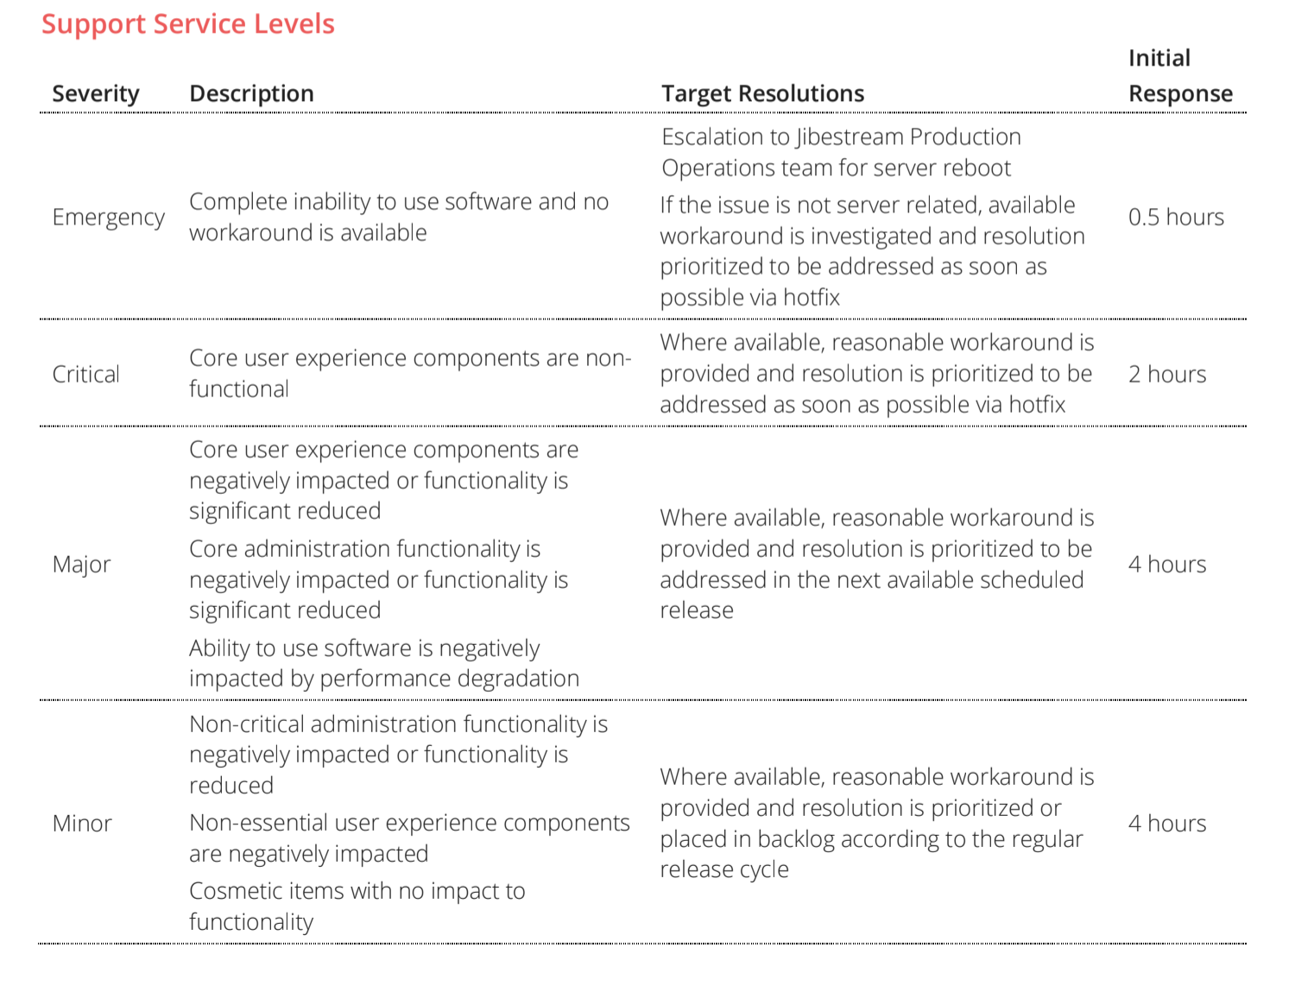

**11. What different types of reports/analytics can be generated?**

Our analytics plugin can be used to easily push data to 3rd party analytics services such as Tableau and Google Analytics. The Jibestream Analytics plugin triggers event notifications based on map interactions.

Analytics and reports on app usage, map usage, heat maps and other relevant analytics can be easily generated.

**User Experience/Mobile App:**

**12. Can we brand the App? Or integrate the App into our MemorialCare App?**

Both of the above is possible.

* 1. Jibestream can provide you with a complete app as per your needs. Services from our app development partners (MobileSmith, Imaginet, etc.) will be leveraged.
  2. Jibestream can leverage your existing app and help integrate the wayfinding features into it. Jibestream’s slogan is “*we put Maps in Apps*”

**13. What are the system’s licensing requirements? Do we have to purchase updates/upgrades in the future?**

Jibestream is a SAAS platform and as such, our clients enjoy the latest and the best in software. The licensing is (generally) based on a per venue basis. A venue is a building. We have been flexible with pricing in the past by doing the pricing based on per square feet.

**14. Is it a native application or web-based?**

We offer both. Jibestream has native SDKs for iOS and Android which can be leveraged for native mobile applications. Jibestream also offers a native Web SDK that can be used for websites, digital signages, kiosks, as well as web-based hybrid apps using WebView framework (Cordova, ionic, phonegap, etc.)

**15. Does their platform have user-friendly tools and templates?**

The CMS is built with a non-technical user in mind. In most cases, we can train people to use them in 2-3 days.

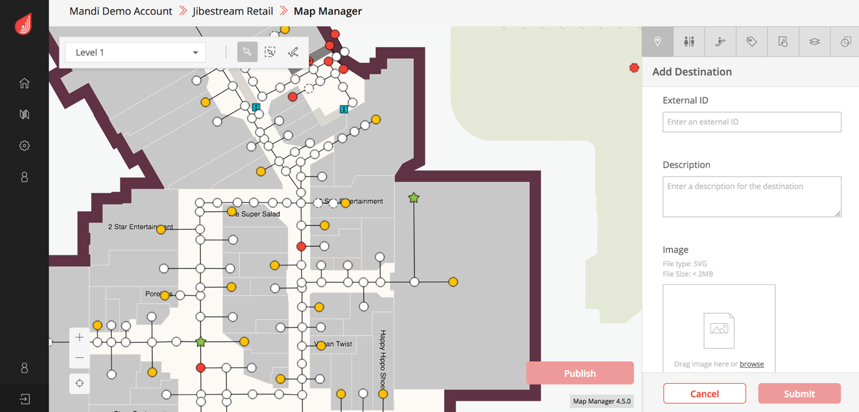

**16. How intuitive/simple is it for the end user? Especially those that may not be super familiar with technology?**

Please refer to answer to question 15.

**17. Do you have any APIs, if so for what kind of functionality?**

Our solution is built on RESTful architecture principles allowing for maximum interoperability between the platform and 3rd party systems and data. We can choose specific APIs and functionality from the SDKs to create tailored solutions while having centralized management of all associated data. In addition, our platform can run inside secure networks and enables you to maintain control of all proprietary data.  
  
Jibestream’s Integration capabilities for both Push and Pull integrations with 3rd party systems enable a wide range of integrations to visualize real-time location data in the context of a map.

Jibestream enables Web API updates from 3rd party systems facilitating integrations from a myriad of sources making it easier to continue to evolve the application over time. Our platform is designed to support the integration of virtually any data with a location component, in the context of a map. Such integrations could include the following and should be discussed further:

• Facilities Management Systems (i.e FM:Systems)  
• Emergency Messaging  
• Asset Tracking and Asset Management  
• Security Systems

• EMR systems

Jibestream Active (‘Swagger”) API documentation: <http://demo-api.jibestream.com/JACS/>

**18. What other languages can your system be produced in?**

Jibestream provides support for multiple UTF-8 languages. Jibestream has a number of commercial deployments around the world (Asia, Europe, Australia, North America) using multiple languages such as Spanish, French, Arabic, Korean, Japanese, Chinese and more.

**Technical:**

**19. Is your system HIPAA compliant?**

Yes

**20. How does your company ensure that all our data is secure?**

Data security is of primary concern to Jibestream.

1. Our platform is trusted by the most secure organizations in the world including The Pentagon, NATO, US Army, Federal and Private Hospitals.
2. Jibestream Security White Paper is attached separately.
3. One important thing I would like to highlight about Jibestream, especially when compared to companies like Phunware, is around **data ownership and data security**.

Unlike phunware, Jibestream does not have access to any of your hospital data. We achieve this because our platform is built with RESTful architecture. Some other companies use this confidential data to create customer profiles which are then sold.

It’s because hospitals and health systems carry so much confidential data, Jibestream’s platform is trusted so much by this industry. I want to refer you to this blog post where we have written in detail about data ownership: [Is your wayfinding partner profiling your patients?](http://www.jibestream.com/blog/is-your-wayfinding-partner-profiling-your-patients)

**21. Where will our data be hosted at? (Cloud, server, etc.)**

Cloud on Microsoft Azure.

**22. Have you integrated with an EMR? If so which ones?**

Yes. We have integrated with EIPC MyChart and can integrate with Cerner and others as well.   
  
**Other Features:**

**23. Other than Wayfinding for our patients/guests what other capabilities would your technology allow us to implement in the future? (i.e. asset tracking, identifying when patients arrive, wait times)?**

Jibestream offers **The Most Number of Use-Cases per Platform (**[**www.jibestream.com/use-cases**](http://www.jibestream.com/use-cases)**)**

It is clear that the immediate need is Blue-Dot wayfinding for guests. In the future, our platform will allow you to add more use-cases for different users (guests, employees, management) to generate more innovative solutions as they become necessary.

* Guest Wayfinding: <https://youtu.be/tIuiekH_cCo>
* Asset Tracking and Status: <https://youtu.be/7k4oXnOiD4A>
* Business Intelligence: <https://youtu.be/32adsry8XU0>
* Security: <https://youtu.be/v25IY7tnP0c>
* Intelligent Parking: <https://youtu.be/BU-kteHVWO8>
* and many more...

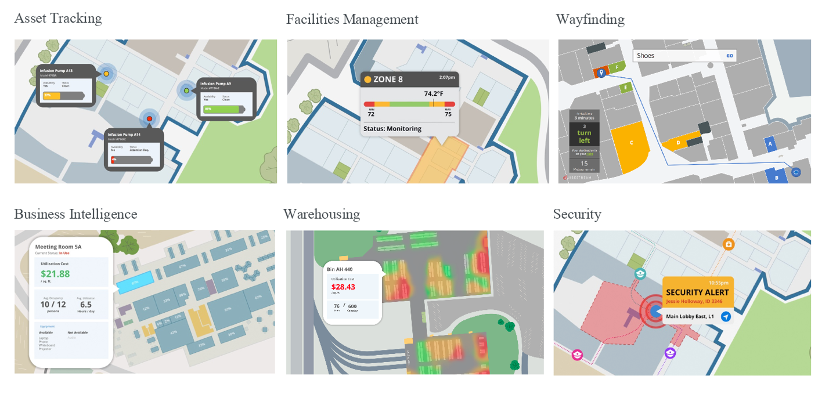

**Digital Signage:**

**24. Do you offer digital signage? If yes, what types?**

Jibestream is a software company that has several digital signage partners. We can refer you to a vendor or bring you the whole solution. This way you won’t have to deal with multiple vendors.

**25. Are we able to customize the digital signage with announcements and advertising?**

Yes.

**26. Is the signage portable or once installed can it not be moved?**

They can be both portable and fixed.

**27. How fast can a technician be sent out to fix any problems with the electronic signs?**

I can reach out to our hardware partners to find answer for this question.

/Users/Jibestream/Desktop/Jibestream_logo-horizontal-colour.png

**Vinay Iyer**, Account Executive

viyer@jibestream.com

647-252-2909

5